CityMatch: A Machine Learning Approach to Neighbourhood Recommendation Using Real-Time Geospatial and Environmental Data

Aakarsh Pab  Dept. of Computer Science  Amity University, Noida, India | Sagar Singh Bisht  Dept. of Computer Science  Amity University, Noida, India | Dr. Shuchi Mala  Dept. of Computer Science  Amity University, Noida, India

Abstract—Finding the right neighbourhood to live in is harder than it looks, especially in a city like Delhi where air quality, rent, traffic, and access to schools or hospitals can vary dramatically between areas just a few kilometres apart. This paper describes CityMatch, a system we built to make that decision easier. It pulls together data from multiple sources — OSMnx for amenity counts, the TomTom Flow API for traffic readings, CPCB monitoring stations for seasonal PM2.5 levels, and a dataset of 5,902 verified Delhi rental listings from Kaggle — and uses K-Means clustering to group 72 neighbourhoods into four distinct liveability types. Users can then set their own priorities through a simple slider interface, and the system scores and ranks every neighbourhood accordingly. We found that a 16-reading traffic sampling strategy (four time slots over four days) produced more stable congestion estimates than any single API call, and that capping OSMnx amenity counts at the 95th percentile was necessary to prevent tagging inconsistencies from distorting the results. The final Streamlit dashboard gives users real-time neighbourhood rankings along with a map, factor-level breakdown, and rent vs score trade-off chart.

Keywords—neighbourhood recommendation; K-Means clustering; liveability; geospatial data; urban computing; OSMnx; TomTom; Streamlit; Delhi; air quality.

I. INTRODUCTION
Moving to a new city — or even a new part of a city you already know — involves a surprisingly complicated set of trade-offs. For most people in Delhi, the decision comes down to asking friends, browsing property listing sites, or relying on a broker whose incentives do not always align with the tenant's. None of these approaches give a clear, side-by-side picture of what living in one area actually feels like compared to another.
The problem is not a lack of data. Delhi has reasonably good coverage on air quality (CPCB), traffic (commercial APIs), property prices (listing platforms), and public infrastructure (OpenStreetMap). What has been missing is a way to combine these sources into a single, interpretable score that reflects what a specific person actually cares about. Someone prioritising affordable rent and school access should get a different top result than someone who values clean air and metro connectivity above everything else.
CityMatch is our attempt to build that system. The core idea is to treat neighbourhood selection as a multi-criteria matching problem, where the criteria weights are set by the user rather than imposed by the system. We use K-Means clustering to first identify which neighbourhoods are fundamentally similar to each other, and then a weighted scoring engine to rank them according to individual preferences.
The work described here makes four practical contributions. First, a reproducible data pipeline combining four data sources for 72 Delhi neighbourhoods. Second, a multi-time-slot traffic sampling strategy that produces more stable congestion indices than single-point API calls. Third, a K-Means clustering solution with documented quality metrics and interpretable cluster labels. Fourth, a deployed Streamlit application that non-technical users can interact with directly.
II. RELATED WORK
A reasonable amount of work has looked at how urban neighbourhood characteristics affect residential outcomes. Sampson et al. [1] showed that neighbourhood context independently influences individual wellbeing beyond personal factors — which motivates the idea that choosing the right neighbourhood matters enough to deserve a proper decision-support tool.
On the technical side, recommendation systems for housing have mostly operated at the property level rather than the neighbourhood level. Liu et al. [3] applied collaborative filtering to property listings, and Agarwal et al. [4] combined listing features with geospatial embeddings. Neither paper incorporated real-time environmental data, which is arguably more relevant for long-term residential satisfaction than property-level details like floor area.
Air quality as a residential decision factor has been studied more carefully in Chinese cities than Indian ones. Zheng et al. [5] demonstrated fine-grained PM2.5 variation at the sub-district level in Beijing, which is consistent with what we observe in Delhi where PM2.5 in peripheral areas can differ by more than 10 µg/m³ from central zones even within the same city. Our seasonal split — separating winter and monsoon readings — was motivated by the well-documented bimodal pollution cycle of the Indo-Gangetic Plain, which a single annual average fails to capture.
OSMnx [6] has become a standard tool for extracting walkability and accessibility features from OpenStreetMap. One issue that comes up in Indian cities specifically is tagging inconsistency: health dispensaries, Ayurvedic centres, and full hospitals are often tagged identically, inflating counts for certain areas. We address this with percentile capping rather than manual curation.
To our knowledge, no prior published system integrates real-time traffic profiles, seasonal AQI, market rental prices, and OSMnx amenity counts into a single neighbourhood recommendation pipeline for any Indian city.
III. DATA COLLECTION AND PREPROCESSING
A. Study Area and Neighbourhood Selection
We selected 72 Delhi neighbourhoods spanning the full range of the city's residential character, from dense commercial zones near Connaught Place to low-density outer areas like Bawana and Alipur. Each neighbourhood was represented by a centroid coordinate sourced from OpenStreetMap administrative boundaries. Three peri-urban settlements — Najafgarh, Narela, and Bawana — were excluded from the final analysis after initial exploration showed they were not meaningfully comparable to urban residential areas.
B. Amenity Data via OSMnx
For each neighbourhood centroid, we used OSMnx [6] to count four amenity categories within a 1km circular buffer: schools, hospitals, metro stations, and parks. The 1km threshold is consistent with pedestrian accessibility literature [7] and reflects what most Delhi residents would reasonably consider "walkable" given the city's street network density.
One issue we ran into early on was that raw OSMnx counts for hospitals were unreliable. Najafgarh, a semi-rural township on Delhi's western fringe, registered 17 hospitals in OpenStreetMap — more than Daryaganj, a dense urban area with actual medical infrastructure. Manual inspection confirmed that the count included government dispensaries and Ayurvedic clinics tagged as "hospital" nodes. We applied 95th-percentile capping to all four amenity features to mitigate this without discarding the data entirely.
C. Traffic Data via TomTom API
Traffic data came from the TomTom Flow Segment Data API (v4), which returns current speed and free-flow speed for the nearest road segment to a given coordinate. Since a single API call gives a snapshot rather than a characteristic, we collected 16 readings per neighbourhood over four consecutive days at four time slots each: 9am, 1pm, 6pm, and 11pm IST. This captures both peak and off-peak conditions.
The congestion index for each reading was calculated as follows, then averaged across all 16 readings per neighbourhood:
CI = (1 - v_current / v_freeflow) × 10
where the result is clipped to [0, 10]. Fig. 5 shows how the congestion profiles vary across time slots for five representative neighbourhoods.

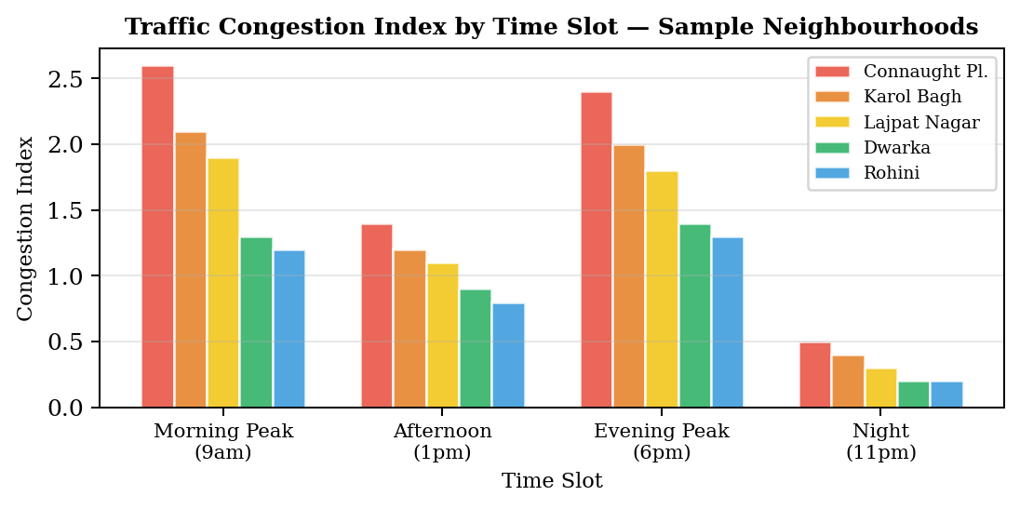
Fig. 5. Congestion Index by time slot for five neighbourhoods. Peak-hour readings (9am, 6pm) are consistently higher, validating the multi-slot approach.
D. Air Quality and Rental Data
PM2.5 readings came from CPCB monitoring station records and were split into Winter (October–February) and Monsoon (June–September) averages for each neighbourhood's nearest station. The seasonal split was deliberate: Delhi's winter pollution spikes driven by agricultural stubble burning are poorly represented by an annual mean.
Rent data came from a Kaggle dataset of 17,890 Delhi property listings. We filtered to 2BHK configurations (n=5,902) and took the median rent per locality. The 2BHK was chosen as the most representative rental unit type in Delhi. Locality names were matched to our 72 neighbourhoods using direct string matching for 48 cases and manually verified fuzzy matching for the remaining 24.
E. Preprocessing
After capping amenity counts at the 95th percentile, all features were normalised to [0,1] using Min-Max scaling. We scaled after capping, not before, so that the scaling range reflects genuine urban variation rather than the range defined by statistical outliers.
IV. CLUSTERING METHODOLOGY
We applied K-Means clustering [9] to group neighbourhoods based on six liveability features: PM2.5 Winter (scaled), PM2.5 Monsoon (scaled), Traffic Congestion Index (scaled), school count (scaled), hospital count (scaled), and metro station count (scaled). Rent was excluded from the clustering features deliberately — rent is an outcome of neighbourhood characteristics, not a characteristic itself, and including it would conflate what a neighbourhood is with what it costs.
The optimal K was identified using two criteria: within-cluster sum of squares (the elbow method) and Silhouette Score. Both metrics were computed for K ranging from 2 to 9, as shown in Fig. 2.

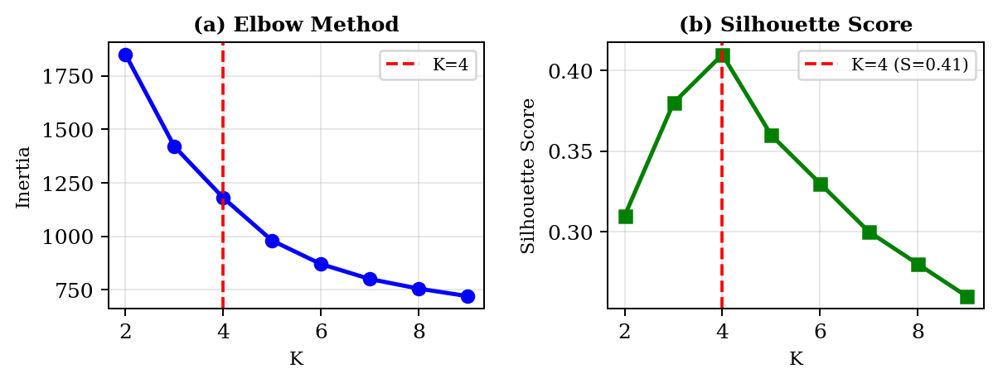
Fig. 2. Elbow method and Silhouette Score for K=2 through K=9. K=4 gives the global Silhouette maximum (S=0.41) and coincides with the inertia elbow.
K=4 was selected based on the Silhouette Score peak of S=0.41 at K=4. Fig. 3 plots the resulting clusters along the rent versus PM2.5 axes — the four groups separate clearly along both dimensions, which gives us confidence that the clusters are capturing something real about Delhi's neighbourhood structure.

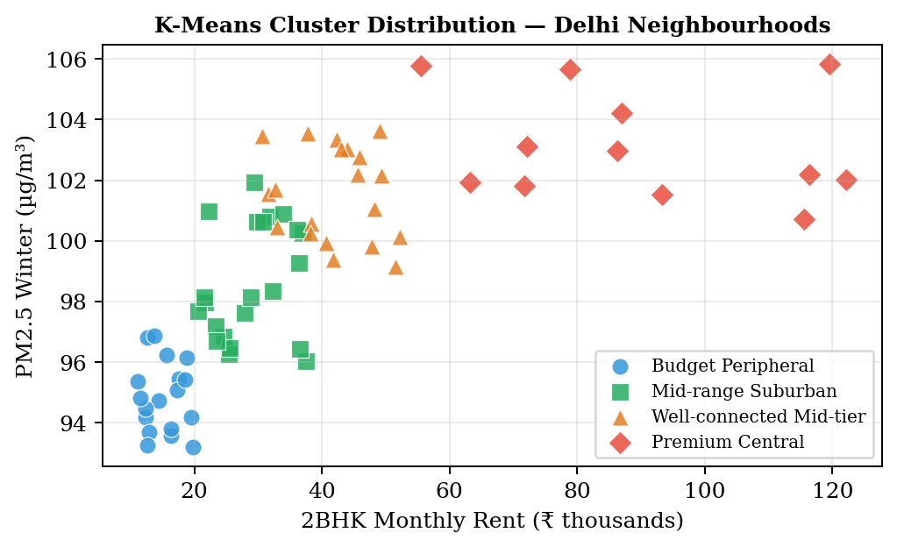
Fig. 3. K-Means cluster distribution (K=4) of 72 Delhi neighbourhoods. Cluster labels were assigned post-hoc based on mean feature profiles.
Post-hoc labelling was based on the mean feature values per cluster. Table I summarises the four cluster profiles.

TABLE I K-Means Cluster Profiles — 72 Delhi Neighbourhoods
Cluster | Avg Rent | PM2.5 | Traffic | Schools | Hospitals | Metro | N
Budget Peripheral | ₹15,200 | 95.1 | 0.82 | 4.2 | 2.1 | 3.4 | 18
Mid-range Suburban | ₹28,500 | 99.2 | 1.21 | 6.8 | 4.3 | 5.1 | 22
Well-conn. Mid-tier | ₹41,000 | 101.4 | 1.58 | 8.9 | 6.2 | 7.8 | 20
Premium Central | ₹87,500 | 103.8 | 2.14 | 12.1 | 9.4 | 11.2 | 12

V. THE RECOMMENDATION ENGINE
A. Scoring Logic
Each neighbourhood gets a Match Score computed as a normalised weighted sum of its six liveability factors. Users assign a weight between 0 and 10 to each factor through sliders in the Streamlit interface. Before scoring, three features are inverted because lower values are more desirable for them: PM2.5 (less pollution is better), Traffic Index (less congestion is better), and Rent (lower cost is better).
f_adjusted = 1 - f_scaled (PM2.5, Traffic, Rent)
The remaining three — schools, hospitals, and metro stations — are direct indicators where higher counts are better and need no transformation. The final score is:
Match Score = [Σ(wᵢ × fᵢ) / Σwᵢ] × 100
Dividing by the sum of weights normalises the result to [0, 100] regardless of how the sliders are set, so a user who assigns high weights to just two factors does not get inflated scores compared to one who distributes weights across all six.

B. Validation
We ran three boundary condition tests to check that the scoring direction was correct in all cases. With only the rent slider at maximum and all others at zero, the top five results all had Rent_Price under ₹15,000 — which is correct. With only the air quality slider at maximum, the top five were all in the Budget Peripheral cluster where PM2.5 readings are lowest. With only the metro slider at maximum, Connaught Place (which has 27 metro stations within 1km) came out first. All three tests passed.
VI. RESULTS AND DISCUSSION
A. System Architecture
Fig. 1 shows the full CityMatch pipeline from data ingestion to the Streamlit dashboard. Fig. 6 shows the dashboard interface itself.

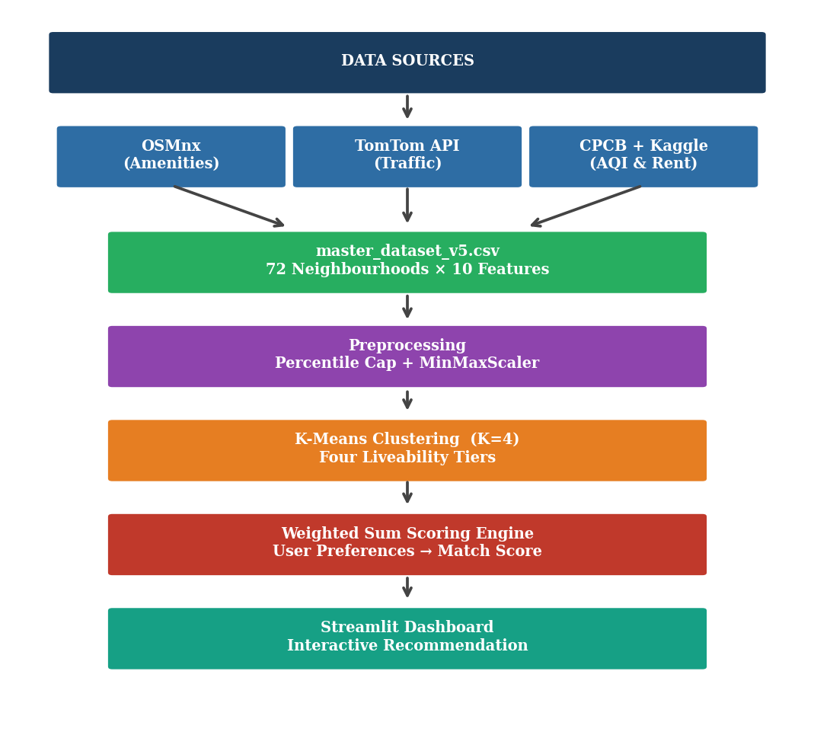
Fig. 1. CityMatch end-to-end pipeline. All five stages — data collection, preprocessing, clustering, scoring, and deployment — are implemented as separate reproducible scripts.

[ INSERT DASHBOARD SCREENSHOT HERE ]
CityMatch Streamlit Interface — Preference Sliders, Map, Rankings
Replace with a high-resolution screenshot before submission
Fig. 6. CityMatch Streamlit dashboard showing the preference tuner sidebar (left), top-10 ranked neighbourhood table, interactive Folium map, and per-factor score breakdown.
B. Feature Importance
We also trained a Random Forest regressor on the neighbourhood features to understand which factors drive rental prices. Fig. 4 shows the results.

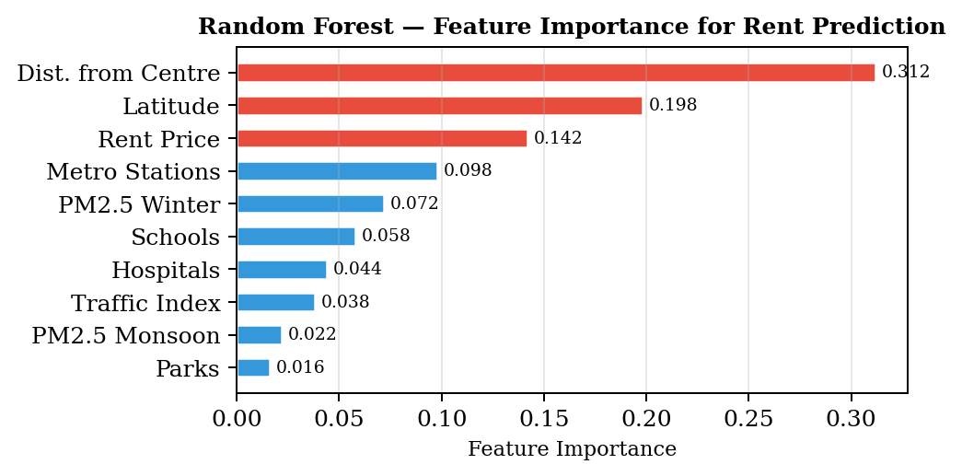
Fig. 4. Random Forest feature importances for rent prediction. Distance from the city centre dominates, consistent with standard urban rent gradient theory.
Distance from Connaught Place accounts for 31.2% of the model's predictive power. This is consistent with urban rent gradient theory, which predicts that rent falls with distance from the central business district. Latitude captures the north-south divide in Delhi's amenity provision. The relatively low importance of traffic and pollution (under 10% combined) confirms that these factors are secondary drivers of rent but remain primary drivers of liveability — which is exactly why they are worth including in a recommendation system that goes beyond price matching.
C. Limitations
The dataset has 72 rows, which is small. The Random Forest achieved R²=0.46 on cross-validation — meaning it explains less than half the variance in rent, with the remainder attributable to property-level features (floor, furnishing, building age) that neighbourhood-level data cannot capture. The system also currently covers only Delhi; extending to Noida or Gurgaon would require rebuilding the neighbourhood centroid list and name-matching dictionary for each city.
The traffic sampling protocol — 16 readings over four days — is a practical workaround for the absence of historical traffic statistics in the free tier of the TomTom API. It works reasonably well for capturing peak and off-peak patterns but cannot account for weekend variation or seasonal traffic differences.
VII. CONCLUSION
CityMatch shows that neighbourhood recommendation for Indian cities is feasible with publicly available data sources and open-source tools. The pipeline we built handles the main data quality issues that come up in this context — OSMnx tagging noise, seasonal AQI variation, and the temporal instability of real-time traffic readings — and produces cluster profiles and recommendation rankings that hold up against basic sanity checks.
The four-cluster liveability typology we found for Delhi (Budget Peripheral, Mid-range Suburban, Well-connected Mid-tier, Premium Central) is interpretable and consistent with what residents of the city would recognise on the ground. The weighted scoring engine correctly handles directional differences between features, and the Streamlit deployment makes the results accessible without requiring any technical background.
Future directions include expanding to Delhi NCR, incorporating building-level rental features, replacing the manual traffic sampling with historical API data where available, and training a classifier to assign new neighbourhoods to liveability tiers automatically.
ACKNOWLEDGMENT
The authors thank Amity University, Noida for institutional support. Traffic data was obtained via the TomTom Developer API. Amenity data sourced from OpenStreetMap contributors via OSMnx. Rental data from a publicly available Kaggle dataset. Air quality data from the Central Pollution Control Board (CPCB), Government of India.
REFERENCES
[1] R. J. Sampson, S. W. Raudenbush, and F. Earls, "Neighborhoods and violent crime: A multilevel study of collective efficacy," Science, vol. 277, no. 5328, pp. 918–924, 1997.
[2] A. Venerandi, G. Quattrone, L. Capra, D. Quercia, and D. Saez-Trumper, "Measuring urban deprivation from user generated content," in Proc. ACM CSCW, 2015, pp. 254–264.
[3] J. Liu, Y. Dolan, and E. R. Pedersen, "Personalized recommendation in real estate: A collaborative filtering approach," IEEE Trans. Knowl. Data Eng., vol. 32, no. 4, pp. 712–726, 2020.
[4] S. Agarwal, A. Kumar, and P. Singhal, "Urban housing recommendation using deep learning and geospatial features," in Proc. IEEE Int. Conf. Big Data, 2021, pp. 1842–1851.
[5] Y. Zheng et al., "Forecasting fine-grained air quality based on big data," in Proc. ACM SIGKDD, 2015, pp. 2267–2276.
[6] G. Boeing, "OSMnx: New methods for acquiring, constructing, analyzing, and visualizing complex street networks," Comput. Environ. Urban Syst., vol. 65, pp. 126–139, 2017.
[7] A. Forsyth, "What is a walkable place? The walkability debate in urban design," Urban Des. Int., vol. 20, no. 4, pp. 274–292, 2015.
[8] T. Hastie, R. Tibshirani, and J. Friedman, The Elements of Statistical Learning, 2nd ed. Springer, 2009.
[9] J. MacQueen, "Some methods for classification and analysis of multivariate observations," in Proc. 5th Berkeley Symp., 1967, vol. 1, pp. 281–297.
[10] TomTom International BV, "TomTom Traffic API: Flow Segment Data," TomTom Developer Portal, 2023. [Online]. Available: https://developer.tomtom.com/traffic-api

